Online Quiz System with Facial Recognition

Tengxiaoyao Tu, Zhicheng Pan, Chao Zhang, Hang Zhou, Yunpeng Bai

School of Computer Science

University of Windsor

Windsor, ON, Canada

{tu6, pan14, zhang1pr, zhou167, bai11e}@uwindsor.ca

ABSTRACT

The current methods for verifying the identity of examinees are subjective and inefficient. In this project, we have done research on methods currently used in face recognition related industries to do verification, studied on how it can be implemented smoothly and efficiently with the online quiz system, finally made improvements on continuous facial recognition. The scope of the project is defined as a student courses registration system, which is integrated with face recognition technologies. The highlight of this project is that it not only features with traditional functionalities of Online Quiz System but also integrates the latest technologies of biometric authentication. It uses web cameras to catch images of a student’s face and identify his permission to log in the system. If the instructor gives a quiz to him, he is asked to do before a camera and continuously censored by facial recognition until the quiz is over otherwise he is kicked out of the system. By using XP, Incremental Model and Agile methods, we have real-time communication among team members regularly through each iteration. Coders pair with each other; pairing programming is practiced throughout the whole project. As a result, we minimize the risk during the design and development of the Quiz System and successfully integrate it with facial recognition.

1 INTRODUCTION

In contemporary software applications, business and even people daily life, security is of utmost significance because if exposed, it may cause massive loss to a person or organization. We can see many new technologies applied and many issues detected in modern software applications or operating systems.

Regarded as an essential subsystem of a school ERP system, Online Quiz System plays a vital role in helping schools, E-learning websites and training institutions to allocate teaching resources and maximize students' and instructors' utilization.

As stated before, the problem is that it often lacks security protection and identity verification. If a courses management system can impose real-time facial recognition on examinees in a quiz or an exam, it will to a large extent reduce the cost both from the students and the teachers including time, management, classroom maintenance, electricity and manual surveillance cost.

At the same time, nowadays artificial intelligence becomes more mature. Facial recognition, as the most mature sub-area of AI, can be applied in various fields. Theoretically, it could be used in any system with authentication modules or replace the old fashion authentication module. It is ready to be commercially launched. Since it is proved feasible in related fields, it is high time that we try to use the most mature, easily accessed and used technology to tackle such a serious problem.

So in this project, we have set out to apply facial recognition to an Online Quiz system in answer to that problem. It not only features with traditional functionalities of Online Quiz System but also integrates the latest technologies of continuous biometric authentication when users are doing the quiz. Its potential customers are those who want to newly launch a brand new Online Quiz System or upgrade their existing legacy system.

The rest of the paper is organized as follows. The project details and methodologies are defined in the next section. The experimental setup is described in Section 3. Finally, the conclusion is the last section.

2 RELATED WORKD

2.1 Project Details and Methodologies

Current facial recognition systems are functional [computer application](https://en.wikipedia.org/wiki/Application_software)s being able to identify or verify users from a live [digital image](https://en.wikipedia.org/wiki/Digital_image) or a [video frame](https://en.wikipedia.org/wiki/Film_frame) from a [video](https://en.wikipedia.org/wiki/Video) source. One of the ways to do this is by comparing selected [facial features](https://en.wikipedia.org/wiki/Face) from the image and a face [database](https://en.wikipedia.org/wiki/Database_management_system). It is typically used in [security systems](https://en.wikipedia.org/wiki/Burglar_alarm) and can be compared to other [biometrics](https://en.wikipedia.org/wiki/Biometrics) such as [fingerprint](https://en.wikipedia.org/wiki/Fingerprint) or eye [iris recognition](https://en.wikipedia.org/wiki/Iris_recognition) systems. [[1]](https://en.wikipedia.org/wiki/Facial_recognition_system#cite_note-Animetrics-1) Recently, it has also become popular as a commercial identification and marketing tool.[[2]](https://en.wikipedia.org/wiki/Facial_recognition_system#cite_note-2)

Face recognition for user authentication comprises two main steps, namely the face detection and recognition. The difficulties in face detection mainly come from two aspects: 1) the large visual variations of human faces in the cluttered backgrounds; 2) the large search space of possible face positions and face sizes. Existing schemes may not be effective for faces due to small-sized faces, lighting and multiple appearance variations, i.e., face recognition for unconstrained video-surveillance environments is a highly demanding task and needs several pre-processing to be usable. [3]

Online quiz or exam is conducting a test online to measure the knowledge of the participants on a given topic. In the olden days, everybody had to gather in a classroom at the same time to take an exam. With online examination, students can do the exam online, in their own time and with their device, regardless where they live. You online need a browser and internet connection. [4]

Figure 1: Final WBS(Work Breakdown Structure)

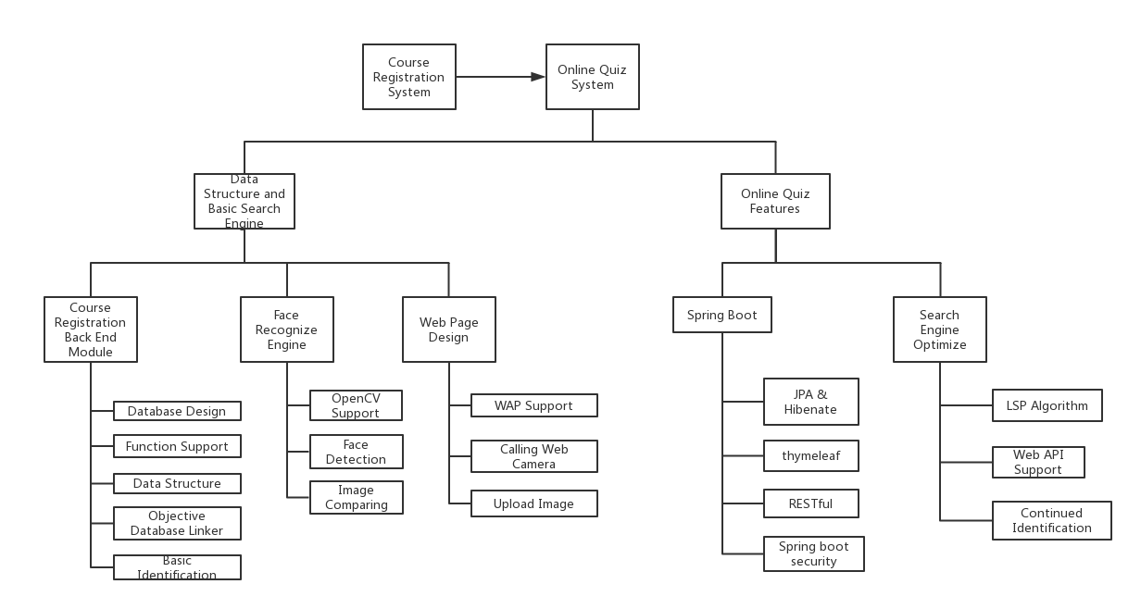

Figure 2: System Flow Chart

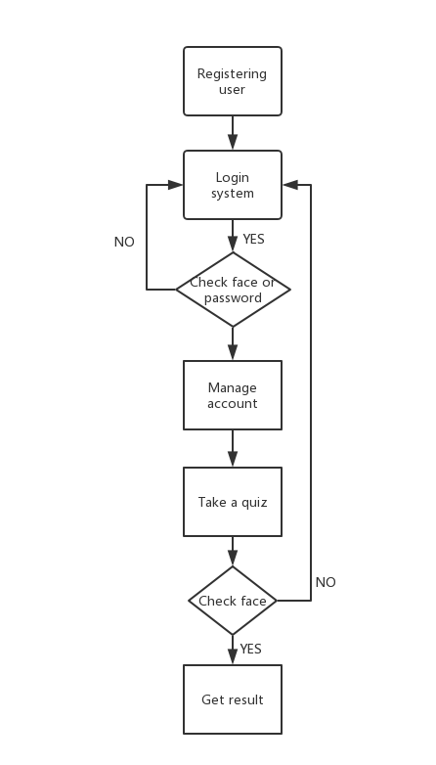

2.2 Methodology

The project is accomplished with incremental development and XP based on agile development methodology. The project aims to develop a basic course system featured with a login module utilized face recognition technologies, and it is finished in 8 weeks and by a team of 5. The most important purpose of this project is to use suitable software engineering methodology to build a completed system. Coders pair with each other; pairing programming is practiced throughout the whole project. The project is managed by Redmine system, so most communication is logged. The iterative circle is every two weeks, and a net meeting is held in every three days. Five members all enroll in coding and switch pairing every week. So that, every member can get familiar with what their counterpart has done by which they get help to finish their part.

2.3 Specification

*2.3.1* Registration

Users that don't have an account or have lost the account may register. When they click on the register button, it goes to register page, and users need to fill in date of birth, address, gender, email, first name, last name, username and password to get an account. Email and username should be distinct. Moreover, the username is encrypted by MD5 encryption, then send to the database. If the email and username input are not repeated, meet the basic requirements, and the user clicks the submit button, the account is created and saved into the database. At the same time, the user is taken two pictures for the instructor to verify the identity of the user when doing the quiz later.

*2.3.2* Login

After creating an account, users may log in the system. When they click on login button, it goes to register page. Users have two ways to log in. They can fill in username and password or open the camera to take a new picture. If users choose to log in by username and password, click the submit button and the username-password combination matches with another one in the database, the user logs in the system. If it does not match, the user may do it again until they make a correct match. If users choose to log in by taking a picture, the system compares the new picture with all the pictures in the database. If it does not match, users are allowed to log in until they give a face picture recognized by the system.

*2.3.3* Course

After creating users’ login, users now have access to the system as a valid user and are present with the index page. When they click on add a course button, it goes to course selection page. Then they are entitled to add a course by either a course number or a course name. If the course number or the course name matches another in the database, the user adds the course. If it does not match, the user may do it again until they make a correct match.

*2.3.4* **Quiz**

After adding a course, users now have access to that specific course if approved and they can that course is shown on the course list page. When they click on that course’s button, it goes to that course’s homepage. After the instructor gives a quiz online, they are required to do that quiz by clicking the quiz button. If the instructor does not specify the number and content of the quiz, the user is presented with 10 random quiz questions in 10 minutes. At the same time, the continuous facial recognition is ongoing. After the user finishes the quiz and clicks the submit button, the system automatically grades the quiz if questions are all objective.

*2.3.5***Facial Recognition**

In this project, When the user is given the quiz, they are responsible for opening the camera and showing the face without leaving the camera’s reach. The camera will first catch one picture of the user and then take one after every ten seconds repeatedly. The system will continuously match the new picture with the two pictures taken when they register. If the camera can not catch their faces, it will automatically warn the user to check the camera or move the face back to the camera. When the camera catches another user’s face or warn the user three times, the chances are that the user is cheating or trying to cheat, the system will shut down the quiz, record the user and course, inform the reason and regulations, and send the user back to the course homepage. Only after the instructor permits and deletes that record on instructor’s account can the user be released and do a new quiz with totally different questions.

2.4 Architecture

*2.4.1* **System Architecture**

Figure 3: System Architecture Diagram

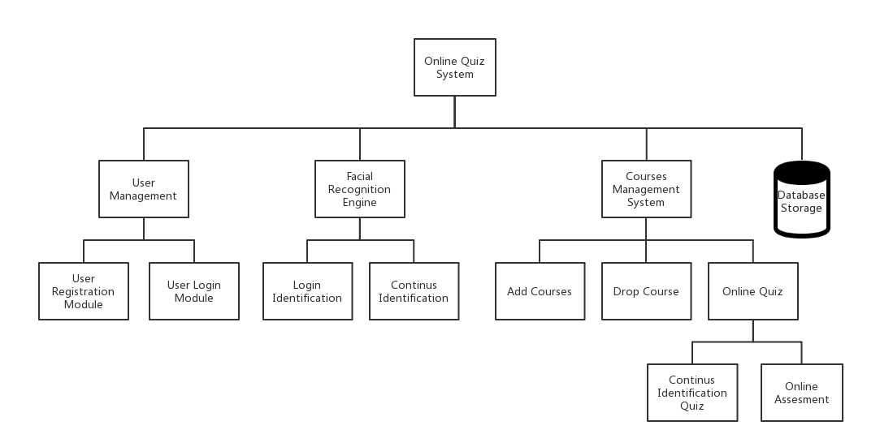

*2.4.2* **Module Description**

1. User Management Module is used to manage users’ actions and accounts, serving as the first firewall of the system.
2. Facial Recognition Engine is used to identify users and guarantee the user is not cheating during the quiz.
3. Courses Management System is used to manage course information and relationship between each course and student. Being part of Courses Management System, the sub-module online quiz is the skeleton of Online Quiz System.
4. Database Storage is used to save all related data produced within last three modules including username, password, Email address, facial pictures, and quiz questions.

2.5 Platform

*2.5.1* On IDE side, for the programming environment’s consistency and compatibility, IntelliJ-IDEA from JetBrains is used for all developers.

*2.5.2* On Cloud side, IBM Bluemix, and CloudFoundry are used to deploy the application.

*2.5.3*For the project’s stability and integrity, the system is designed to be based on Spring Boot framework to build B/S server with critical technologies including Restful and AJAX used.

2.6 Design

Figure 4: Gantt Chart of the Project Schedule

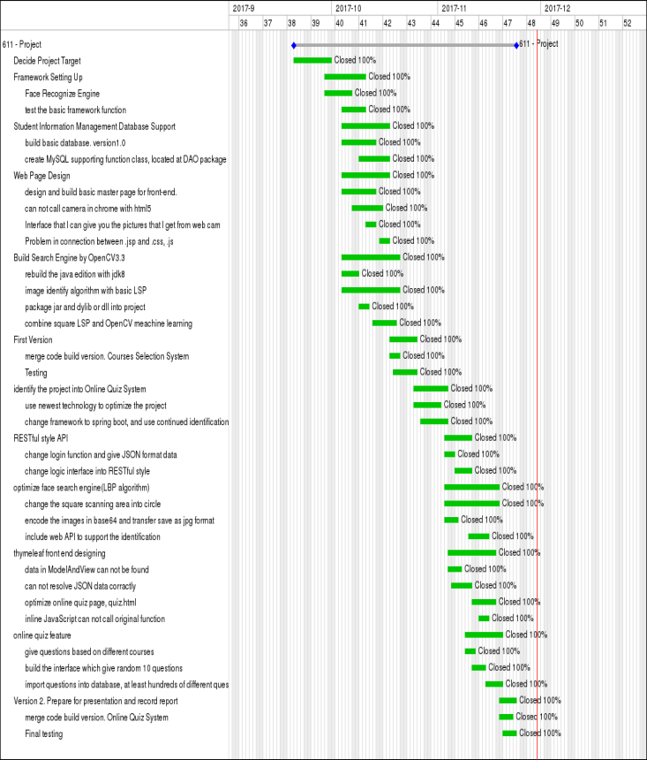

Figure 4: Entity Relationship Diagram

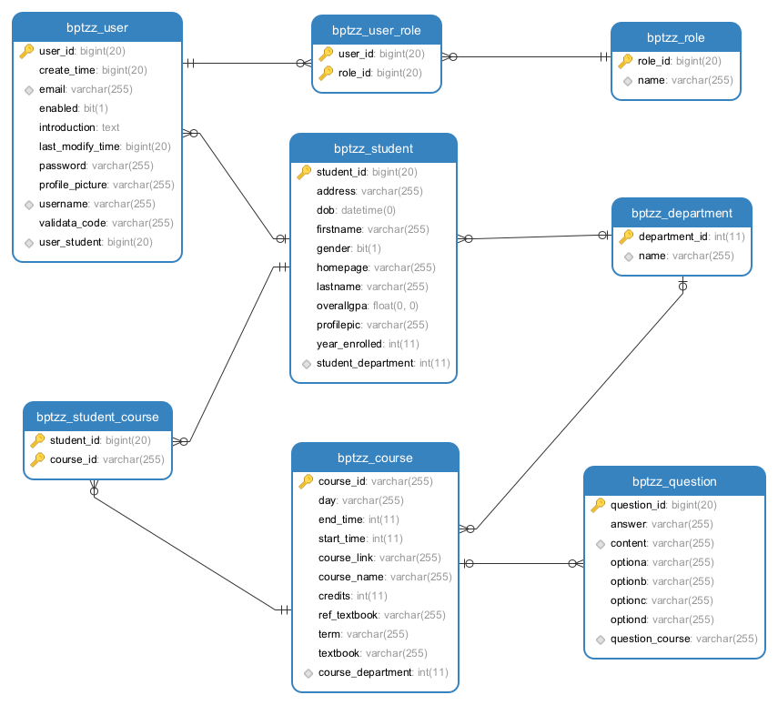

*2.6.1*The project is required to directly gain the data stream of the web camera from web client side, with key technologies including HTML5, Thymeleaf and AJAX used to gain data.

*2.6.2* The server is required to process bio-data and identify users with OpenCV3.3 class libraries called to implement facial recognition and image comparing.

2.6.3 Hibernate is used as a tool for persistently object-relational storage and query, with AJAX completing front-end and back-end fast interaction of data.

2.6.4 This project is coursework project of Software Engineering with MySQL database used to both improve portability and reduce the complexity of database environment configuration.

3 EXPERIMENTAL SETUP

3.1 Implementation Details

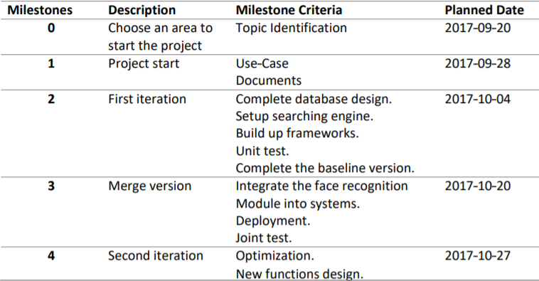

Table 1: Schedule and Milestones

We develop a course selection system which helps students select courses and manage records. Meanwhile, facial recognition in a biometric way is required to authenticate students’ and teachers’ login. This system is required to be back-end manageable; system administrators can configure several key settings; teachers can use the system to call the roll; students can log in, access classes, manage personal information and query test results through facial recognition and authentication. The project is accessible on both mobile phones and web pages.

3.2 Testing

Table 2: Sample User Test Cases

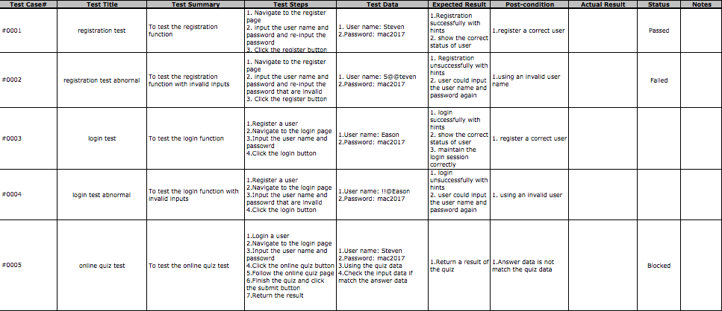

Regarding testing, we strictly follow the testing lifecycle and principles introduced in software engineering course. We develop 20 test cases that use both white box testing and black box testing cases. Besides, unit testing is used by which minimal individual units, sets of system modules together with associated control data, usage procedures, and operating procedures, are tested to determine whether they are fit for use. [4]

4 CONCLUSIONS

In summary, we have performed an experimental study on and designed the face recognition system. The experimental and designing results have been successful that facial recognition in a biometric way authenticates online quiz, students’ and teachers’ login. We finished all planned requirements for the duration of the project, two months.

ACKNOWLEDGMENTS

We would like to express our most profound appreciation to all those who have provided us help and given us the advice to complete this project and report.  We want to give a special gratitude to our Advanced Software Engineering course professor, Mr. Pooya Moradian Zadeh, whose contribution in suggestions and encouragement did great benefit to our project especially in writing this report.

REFERENCES

|  |  |
| --- | --- |
| [1] | ["Face Recognition Applications"](http://www.animetrics.com/technology/frapplications.html). Animetrics. Retrieved 2008-06-04.  http://www.animetrics.com/technology/frapplications.html |
| [2] | ["Facial Recognition: Who's Tracking You in Public?"](http://www.consumerreports.org/privacy/facial-recognition-who-is-tracking-you-in-public1). Consumer Reports. Retrieved 2016-04-05.  https://www.consumerreports.org/privacy/facial-recognition-who-is-tracking-you-in-public1 |
| [3] | Ping Wang, Wen-Hui Lin, Kuo-Ming Chao, Chi-Chun Lo. A Face-Recognition Approach Using Deep Reinforcement Learning Approach for User Authentication. [E-Business Engineering (ICEBE), 2017 IEEE 14th International Conference](http://ieeexplore.ieee.org.ledproxy2.uwindsor.ca/xpl/mostRecentIssue.jsp?punumber=8118205) Electronic. ISBN: 978-1-5386-1412-9. |
| [4] | ["What is online examination?"](http://www.consumerreports.org/privacy/facial-recognition-who-is-tracking-you-in-public1)  https://www.onlineexambuilder.com/help/exam-knowledge-center/what-is-online-examination/item10247 |
| [5] | Kolawa, Adam; Huizinga, Dorota (2007). [Automated Defect Prevention: Best Practices in Software Management](http://www.wiley.com/WileyCDA/WileyTitle/productCd-0470042125.html). Wiley-IEEE Computer Society Press. p. 75. [ISBN](https://en.wikipedia.org/wiki/International_Standard_Book_Number) [0-470-04212-5](https://en.wikipedia.org/wiki/Special:BookSources/0-470-04212-5). |